**E.R.A (Event Registration Application) V 2.0**

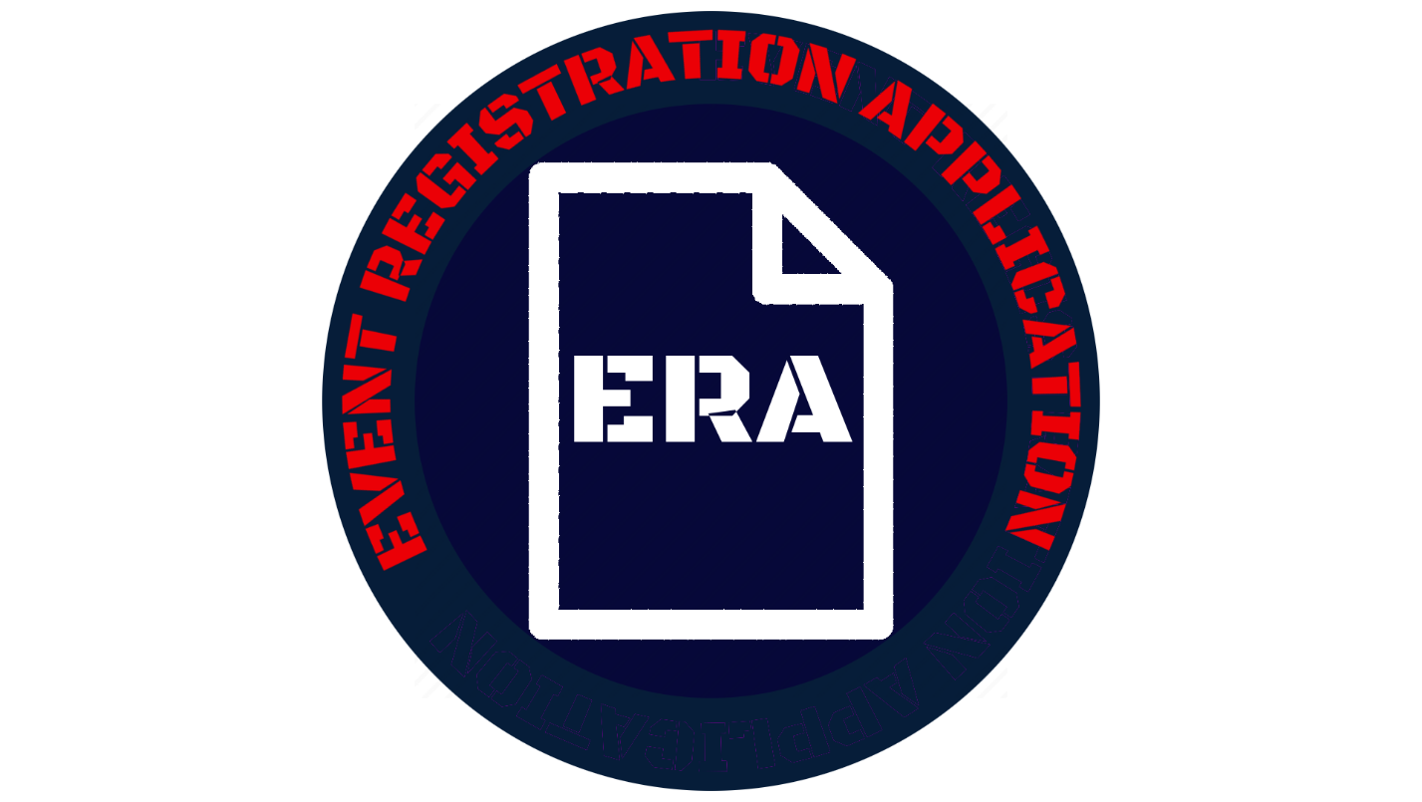

**SUMMARY**

The Event Registration Application Version 2 or ERA V 2.0 is the next iteration of the dynamic tool that organizers across the US Airforce can use to create and manage events using SharePoint Online. It adds commonly requested features and enhancements to improve ERA and refine it into a superior tool.

* Created by AFGSC/DSK at Barksdale AFB.
* Designed to meet the need for a new Event Registration site after SharePoint Tech support announced the decomissioning of the original without a backup tool.
* Not for creating a replacement to address the needs of a particular event registration site, but to create a single tool that was built to address the needs of *any* event registration site so that it can be shared Airforce wide.
* Limitied level of customizeability for personell with software development background. View settings must be done through CSS (Cascading Style Sheets) on modern site.
* Designed to automate as many actions with creating and registering for events as possible such as email notifcations and self-signup.
* Designed to be as intuitive as possible with controls and features that users will be able to learn by using the application and referring to documnetation.

**DISCLAIMER:**

For any issues with installation or use, please contact your SCA Admin first before contacting AFGSC/DSK. ERA has been thouroghly tested and certain features or functions may vary by individual site settings where installed. You can contact us if needed at <AFGSC.KM.Workflow@us.af.mil>

The following page is a credits section that lists the AFGSC/DSK KM shop as the development shop for ERA V 2.0, the team members in the shop who developed it, and their respective roles in the creation of this app. It is in no way meant to be a contact-support index to be used if any problems are found with ERA.

The screenshots used for walkthroughs and setups in this document feature purely “dummy” data to demo events and in no way represent actual events or any of their accompanying information used in actual service.

AFGSC/DSK



DEVELOPMENT TEAM

|  |  |
| --- | --- |
| Product Owner | Carl Canuel SrA, AFGSC |
| Lead/Developer | Josh Gardiner, Peerless Technologies |
| Support Developer | Stephen Burtrum SSgt, AFGSC |

# INSTALLATION AND DEPLOYMENTe

!!!IMPORTANT PRE-REQUISITE!!! Please *DO NOT* use ERA V 2.0 with Internet Explorer! Microsoft Edge, Google Chrome, and Firefox are the recommended browsers for this application.

1. Create a sub-site in SharePoint where you want ERA V 2.0 to live and navigate to it.

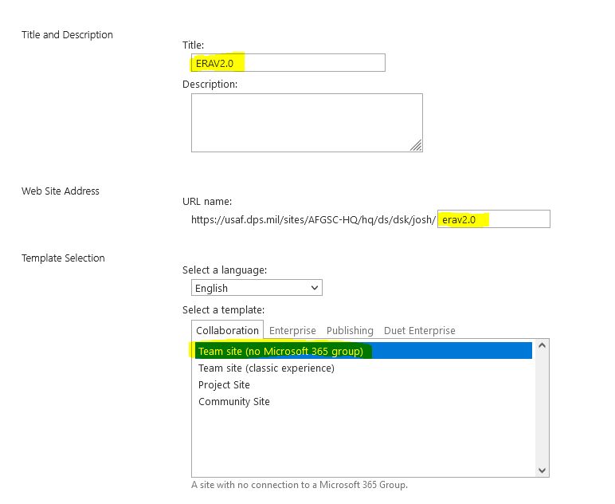

1. Click Site content -> Site Assets.

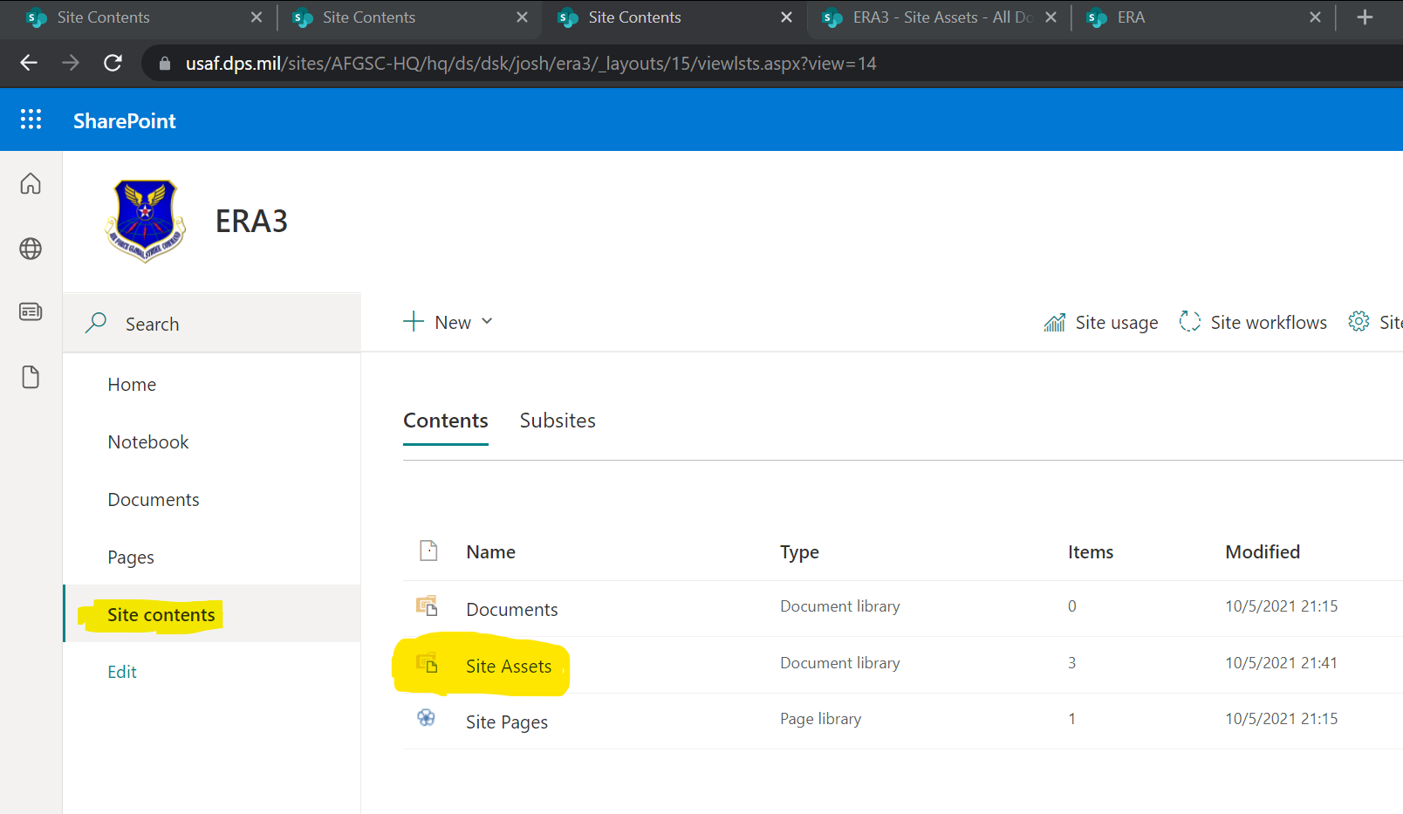

1. Create a new folder and name it “Event-Registration”

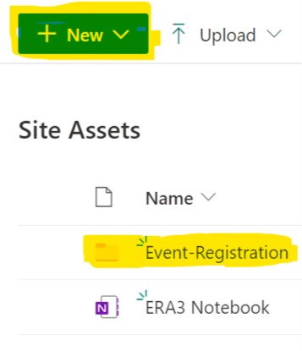

1. Click inside of the Event-Registration folder. And upload the following files accompanying this document.

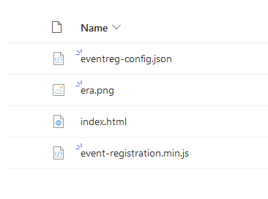

1. Click “Pages” in the left pane as highlighted below.

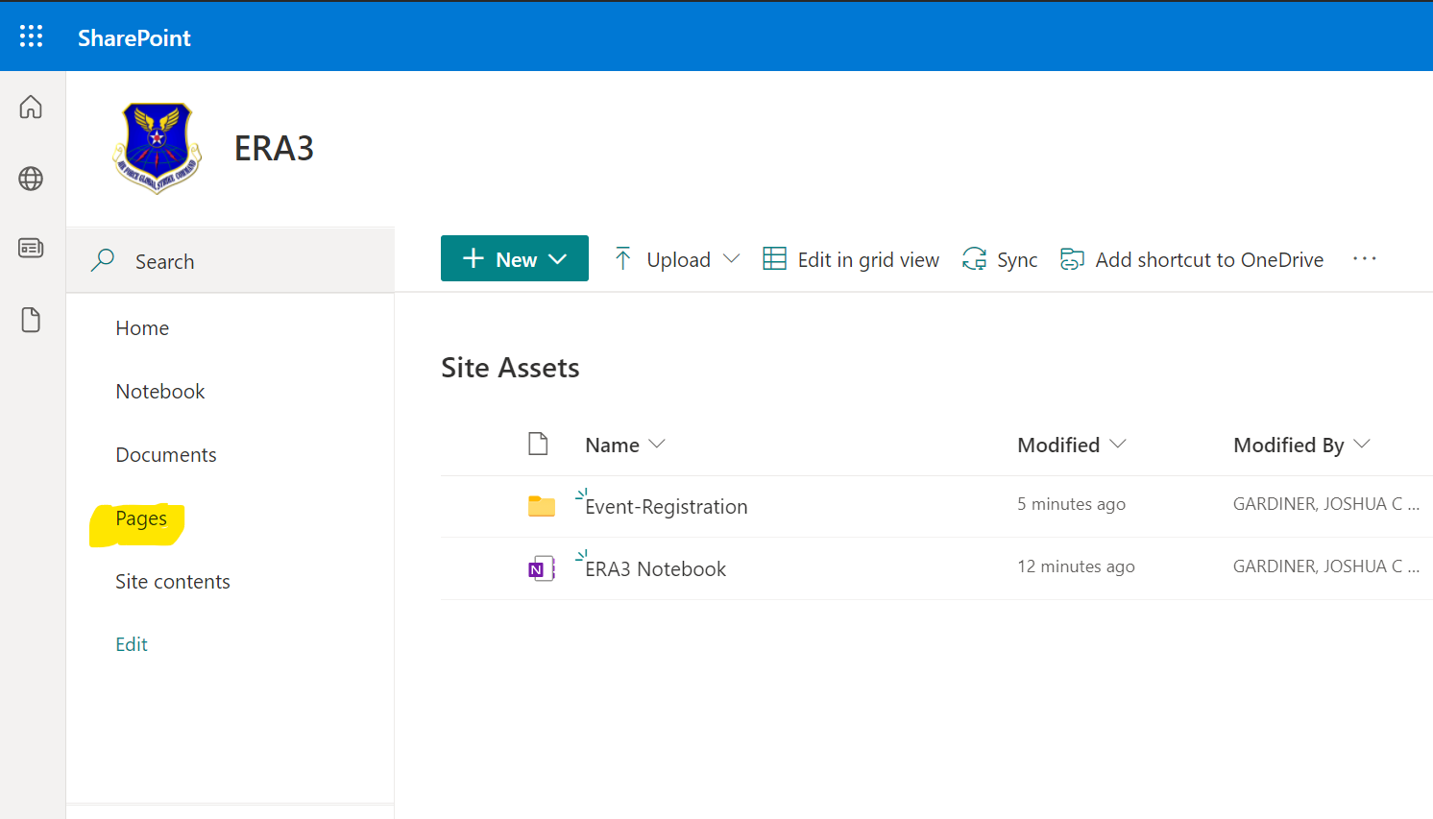

Page will appear as below.

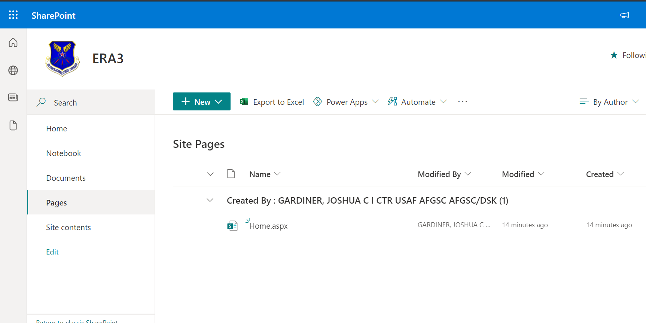

1. Click New -> Web Part Page.

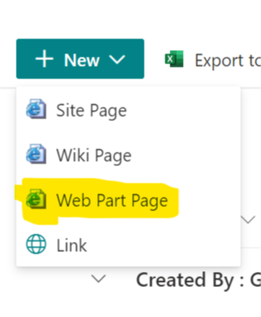

Page will appear as below.

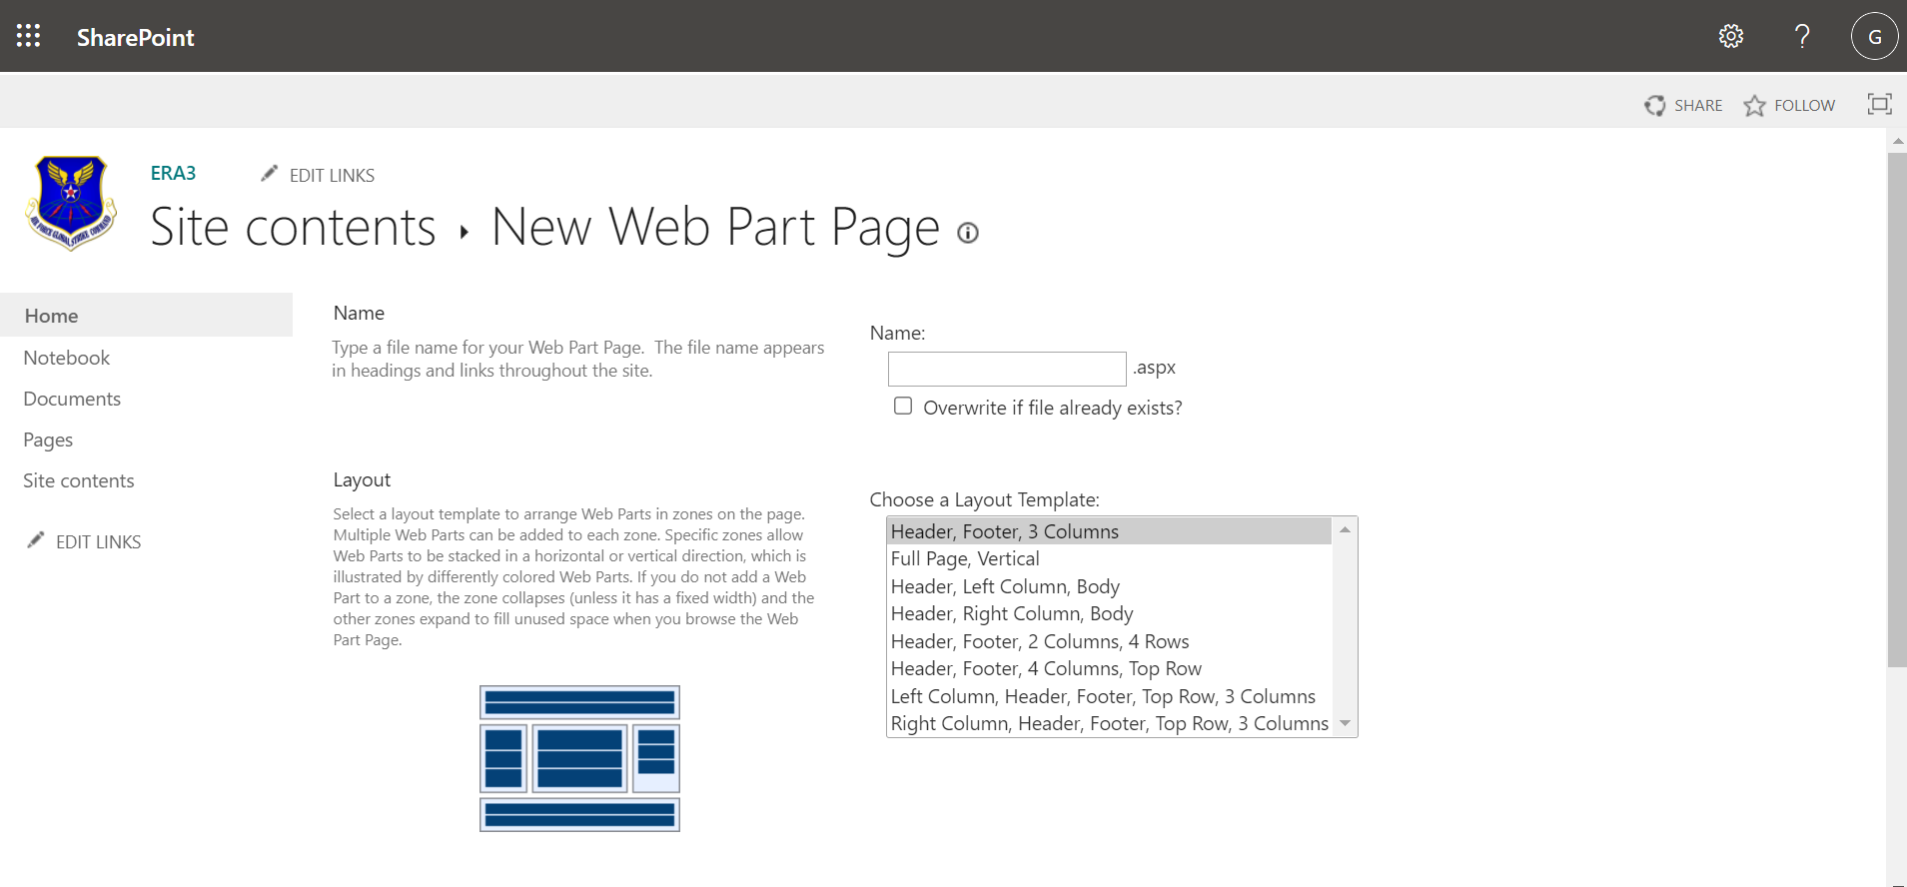

1. Type the name you want to name your site before “.aspx”. In the example below the page is named ERA

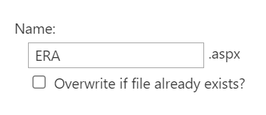

1. Select “Full Page, Vertical” for layout template.

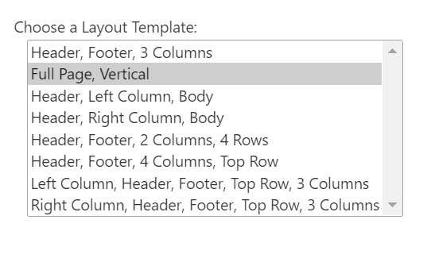

1. Leave “Document Library” as “Site Assets” as in screenshot below.

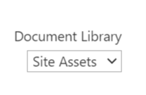

Page will appear as below.

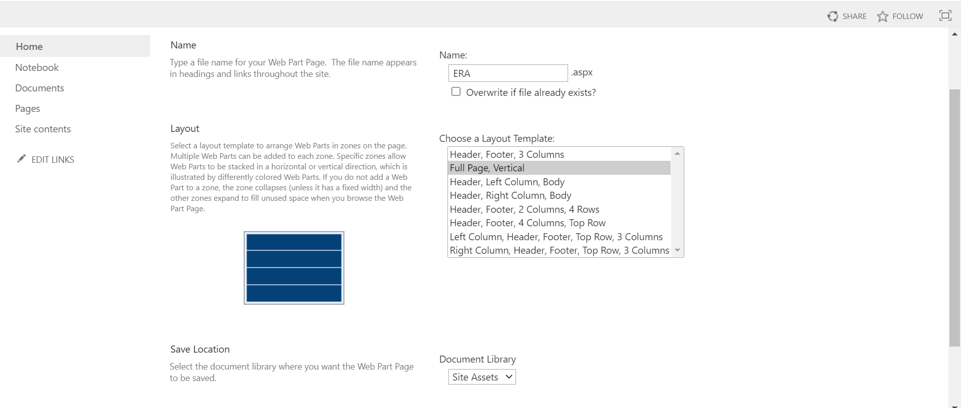

1. Click “Create” at the bottom of the page.

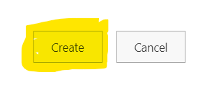

Expected Result: You will now be taken to the page below.

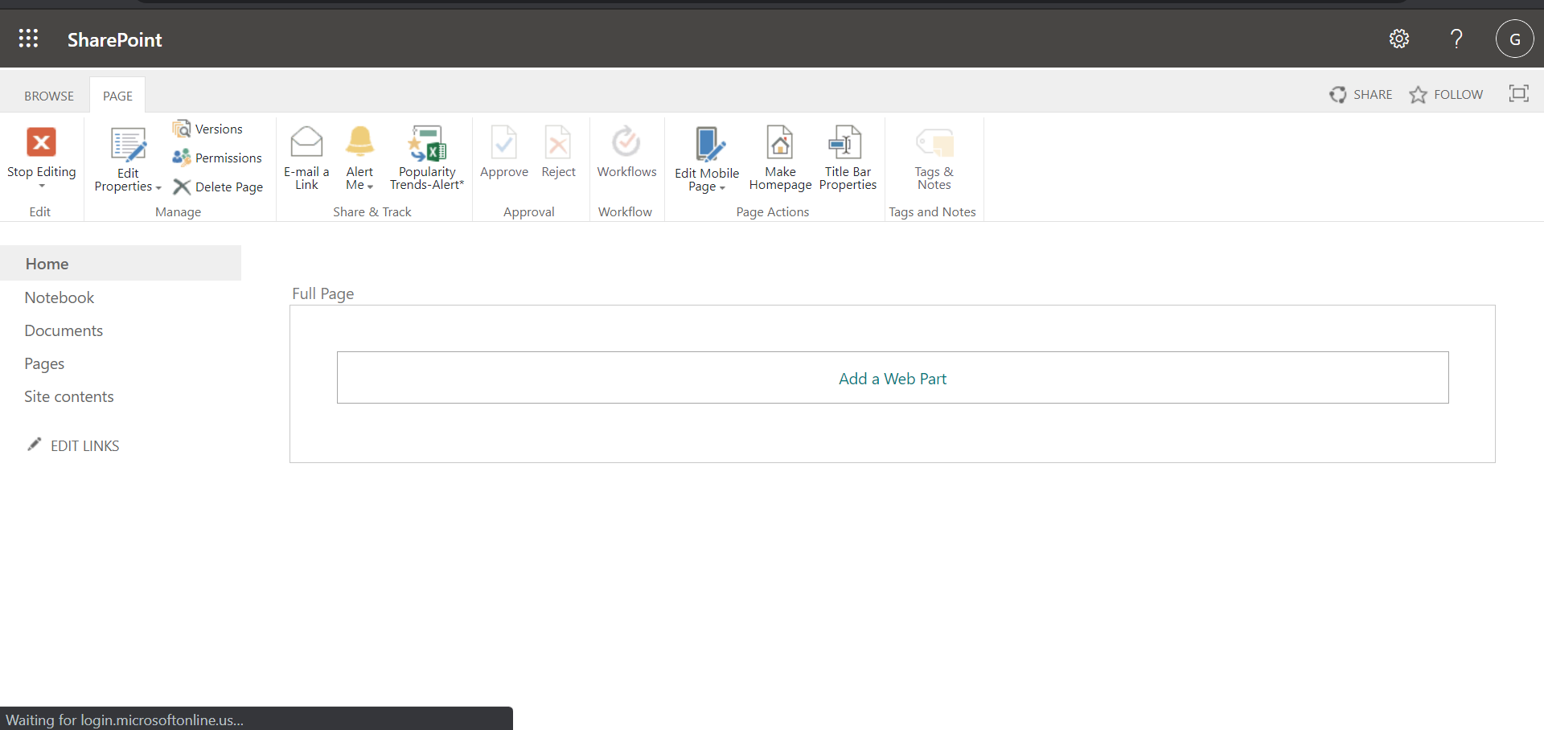

1. Exit out of the current tab and return to “Site Contents” -> “Site Assets”.

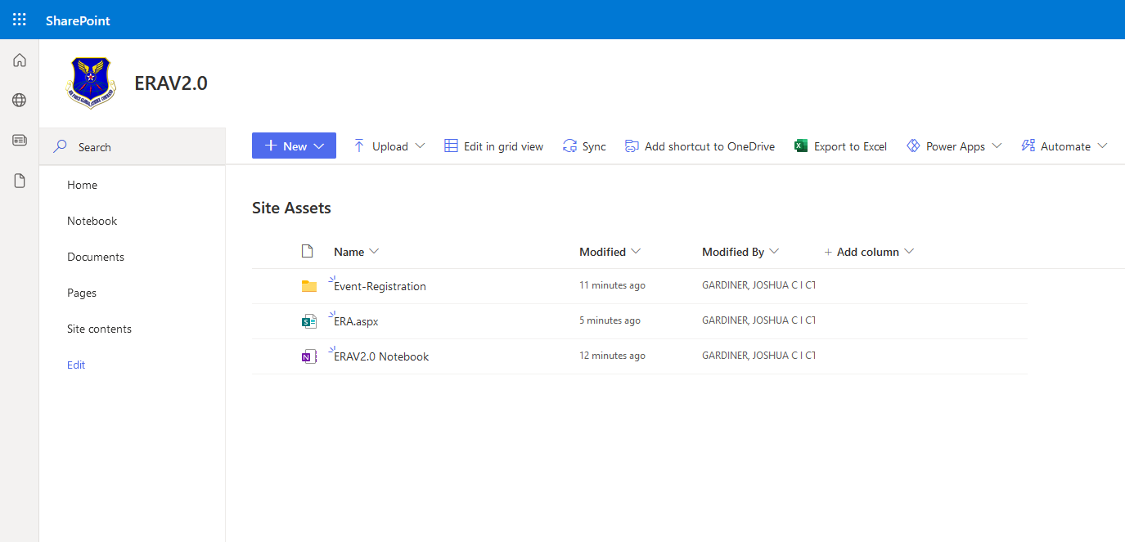

1. Move the “.aspx” file created in Step 10) to the Event-Registration folder created in

Step 3).

Page will appear as below.

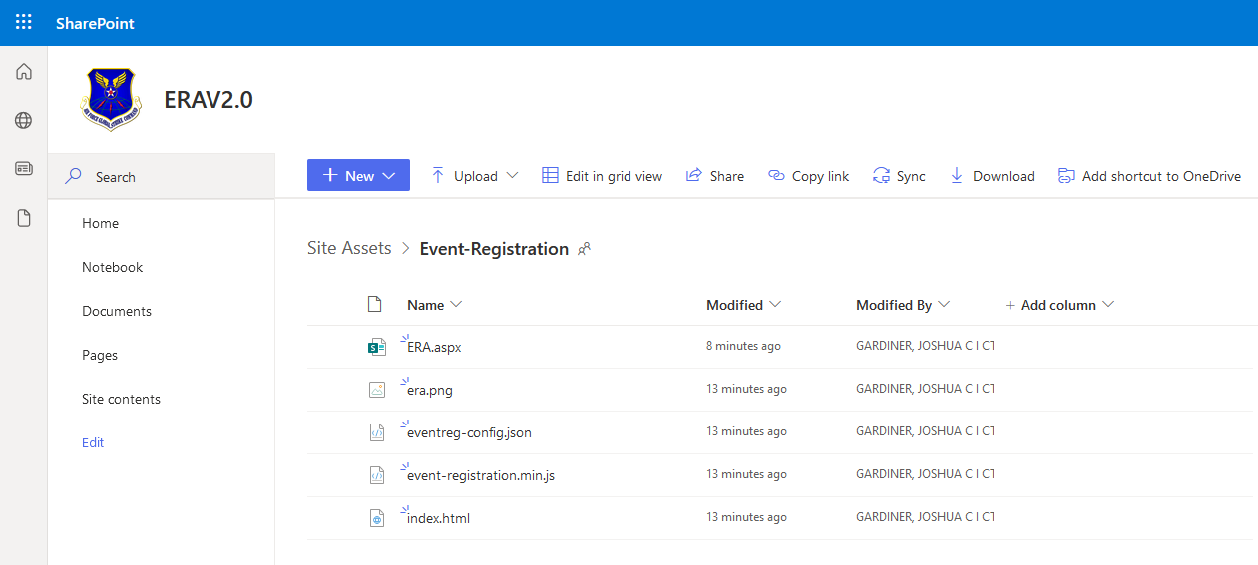

1. Click the “.aspx” file, then click the Page tab on the ribbon above and then the Edit Page button.

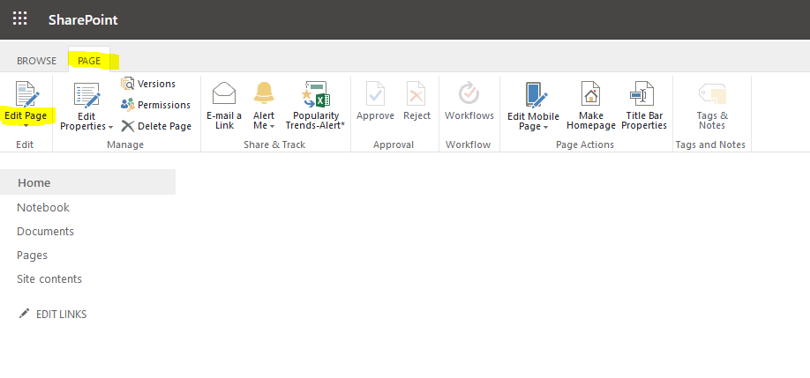

Expected Result: The page will appear as below.

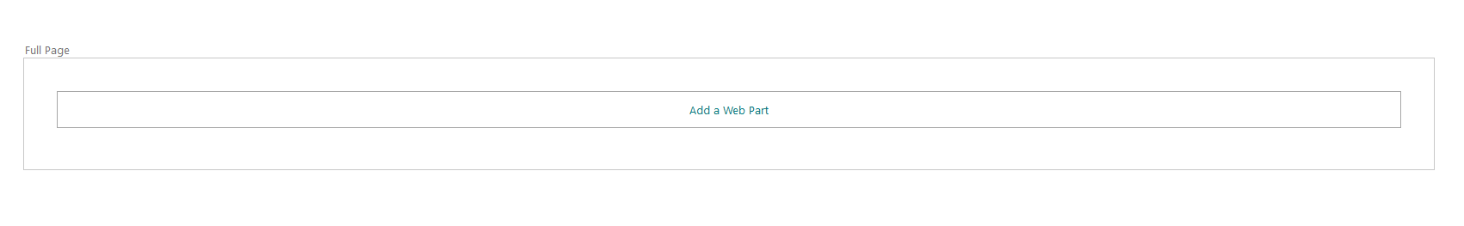

1. Click “Add a Web Part” in the center of the screen as in the below screenshot.

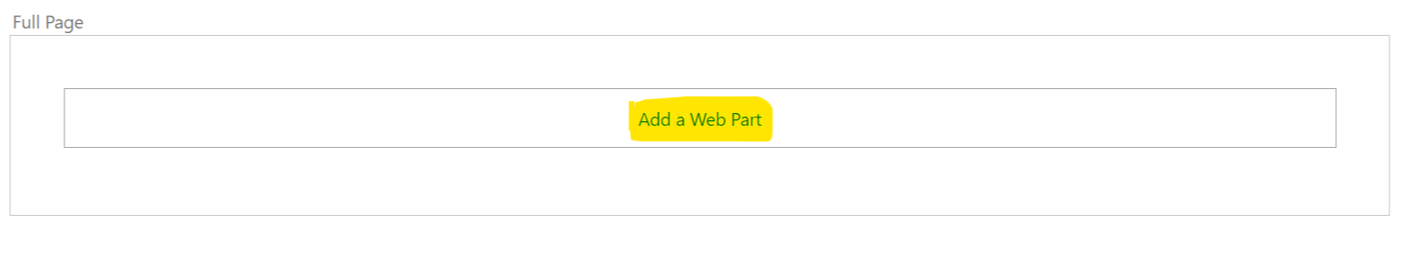

Page will appear as below.

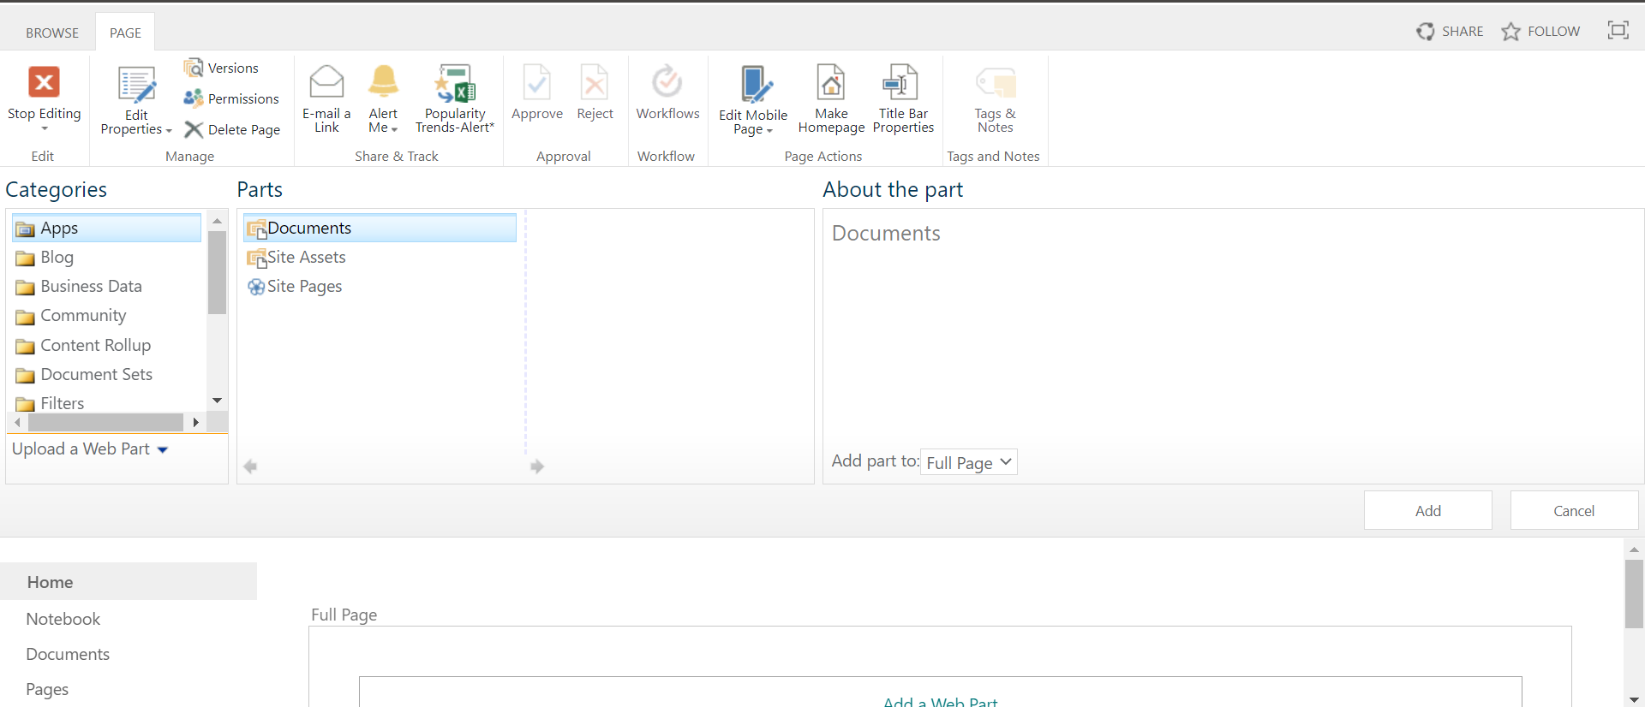

1. Under Categories scroll down and click “Media and Content”

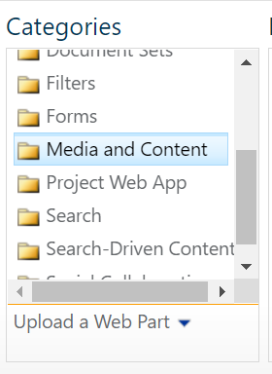

Page will appear as below.

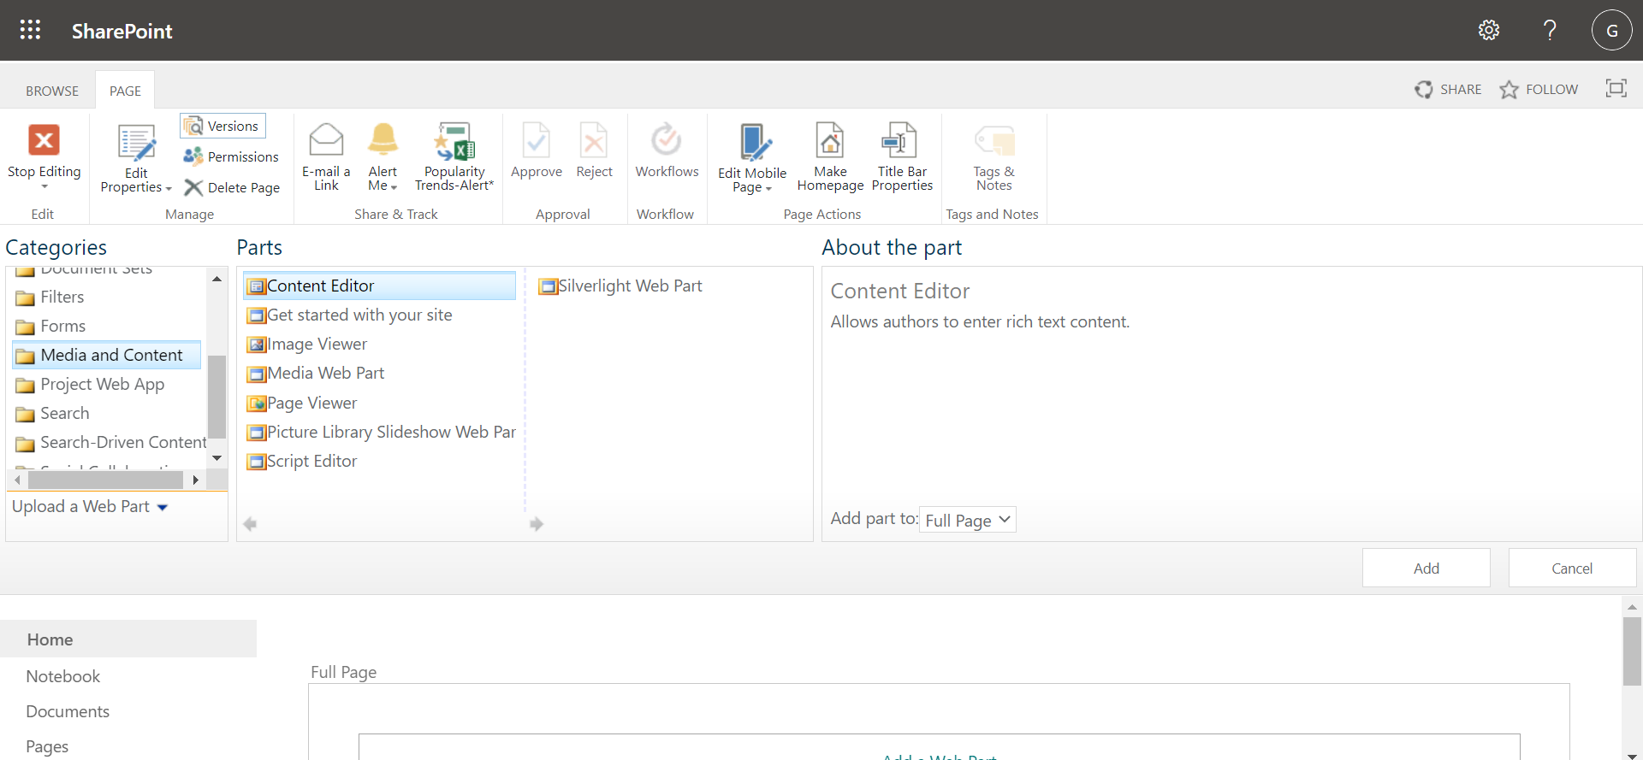

1. Click “Add” button



Page will appear as below.

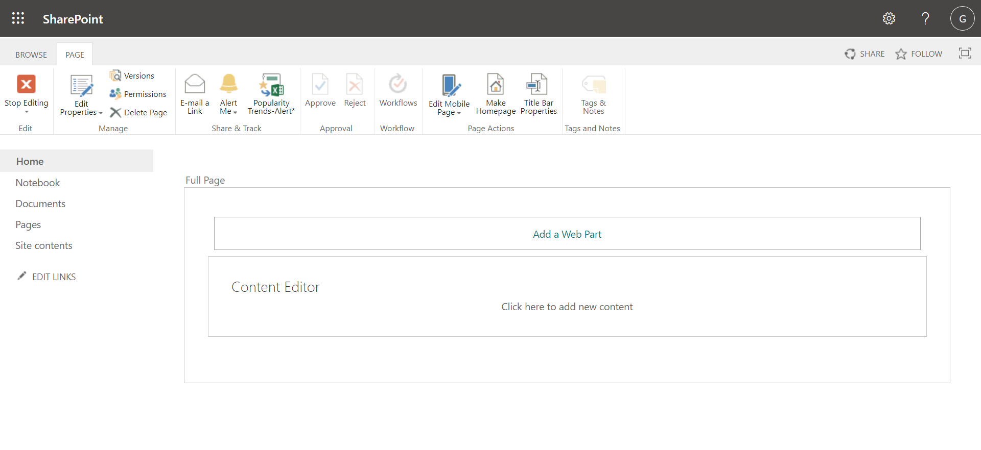

1. Check the tiny box in the upper right corner, click the dropdown arrow in front of it, and choose “Edit Web Part”

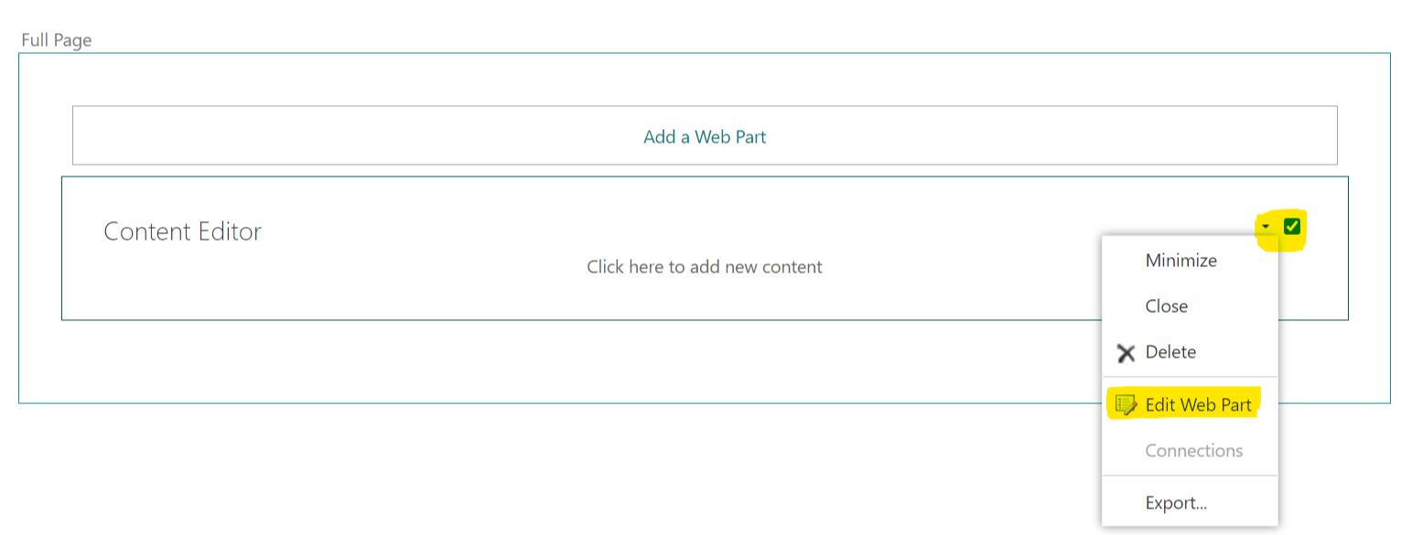

Page will appear as below.

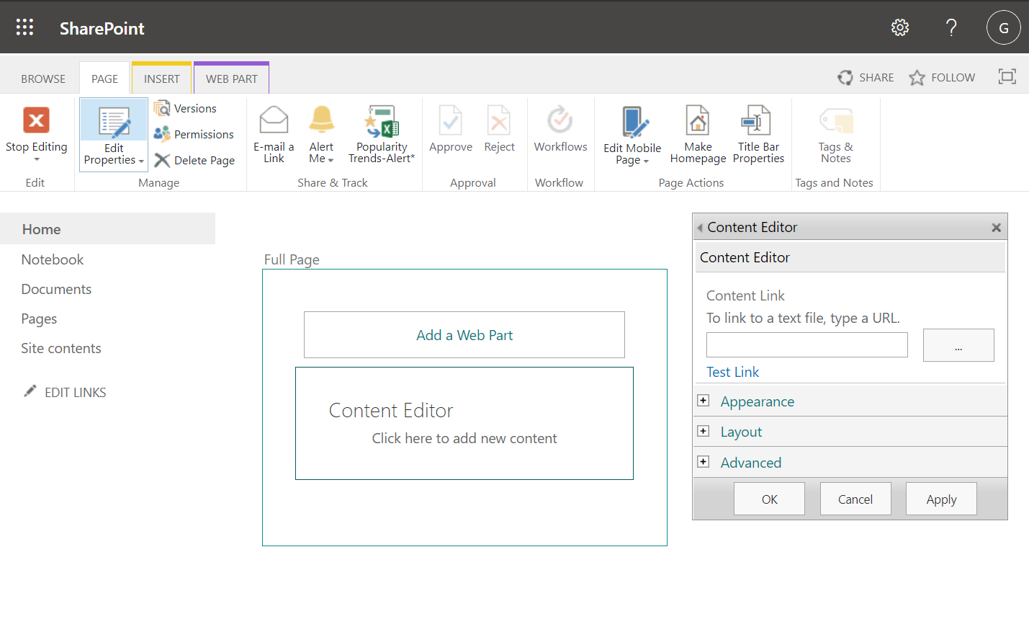

1. Type “./index.html” into the URL box as in the screenshot below:

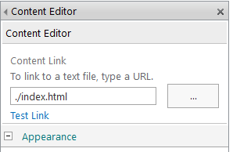

1. Click the “+” next to Appearance.

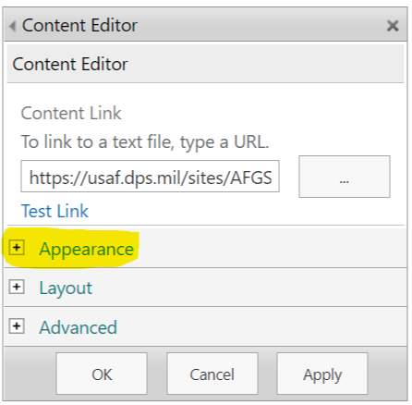

Page will appear as below.

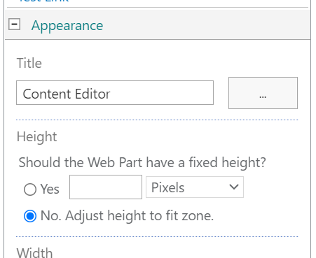

1. Scroll down to “Chrome Type” and set it to “None”

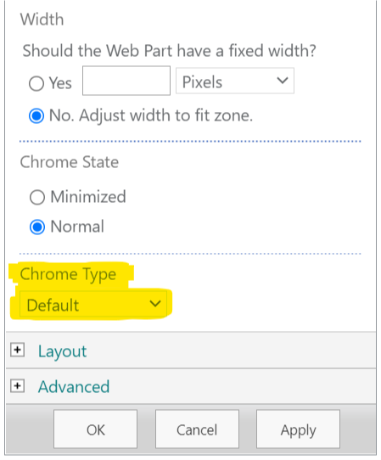

Page will appear as below.

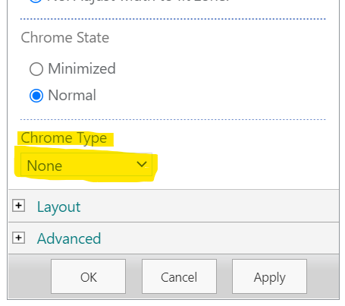

1. Click “OK”
2. Click Install on the “Installation Required” screen.

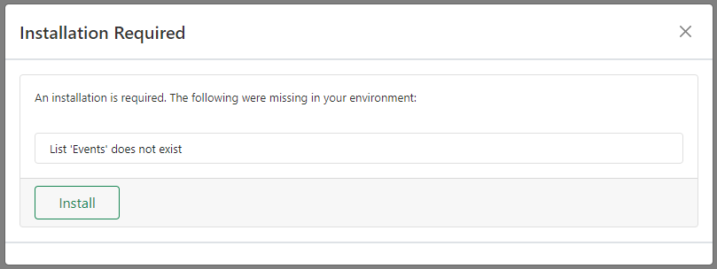

1. Click Refresh after installation is loaded.

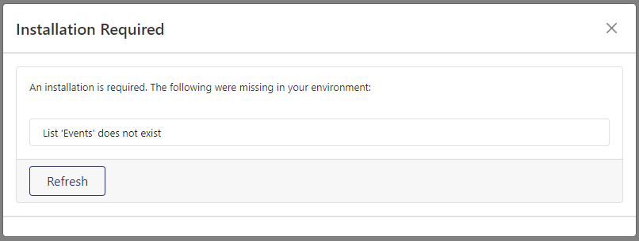

1. Click Stop Editing in the upper left.

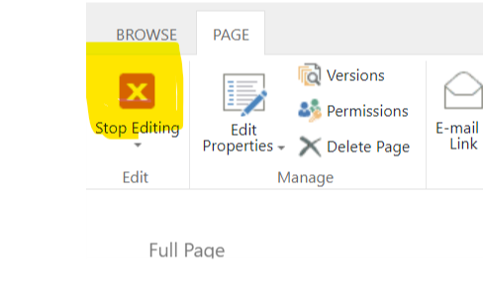

!!!IMPROTANT!!! Steps 25 and 26 are ONLY recommended if this has been created on its own sub-site.

1. Click the cog-wheel in the upper right-hand side of the page. Click “Edit Page”

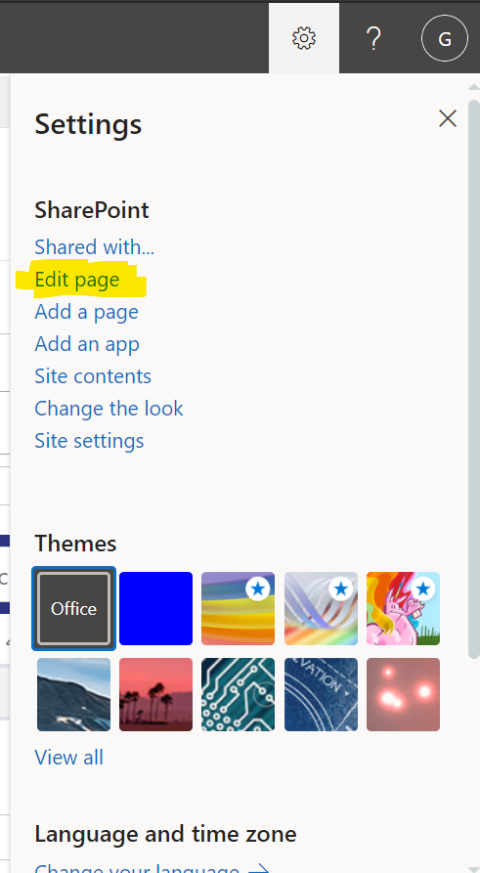

1. Click “Make Home Page” on the Page ribbon.

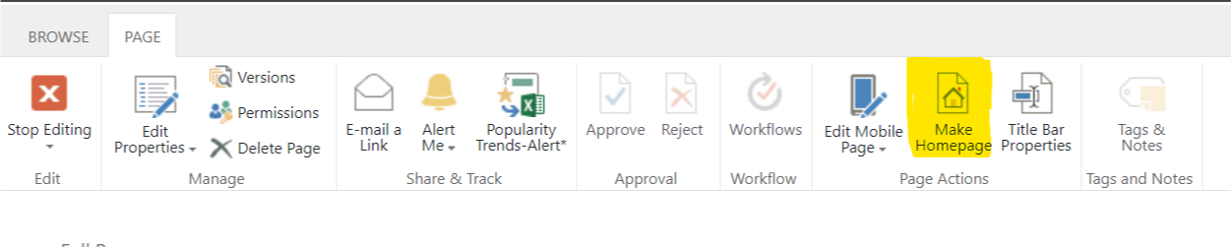

1. CONGRATUALTIONS!!! ERA is now ready to go! It will appear similar to the screenshot below.

After Fresh Install:

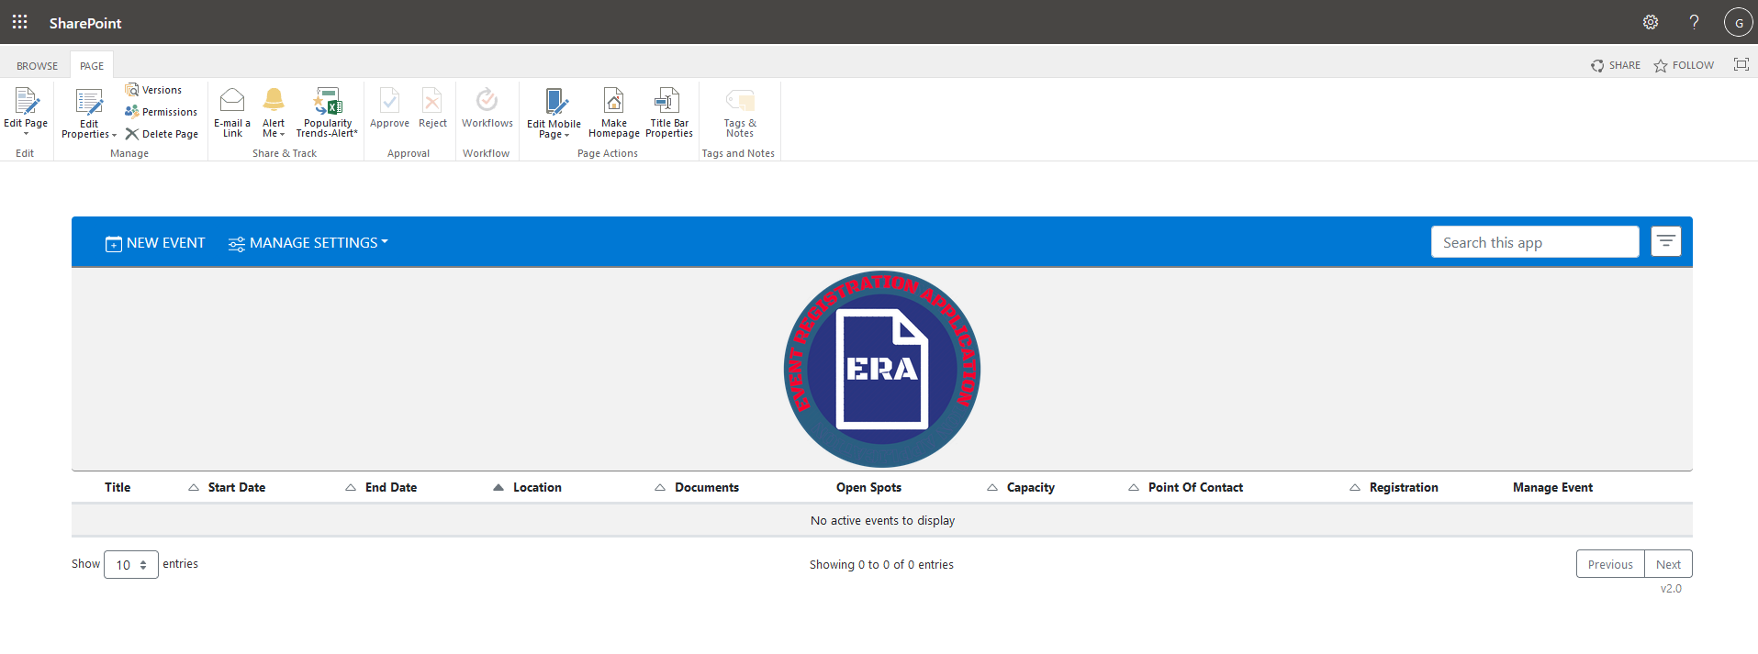

After adding data:

